March 20, 2018 Contact: Kevin Havas
Project Manager
(908)451-1028

PRESS RELEASE
Team ACLC awarded TRADOC Army Virtual Learning Environment (A-VLE) Contract

Fort Eustis, VA – Eduworks Corporation, as part of Team ACLC, has been awarded one of six prime positions on the 5-year, $294 million Army Virtual Learning Environment (A-VLE) Indefinite Delivery/Indefinite Quantity (IDIQ) contract for the US Army Training and Doctrine Command (TRADOC). Under A-VLE, Team ACLC will support analysis, design, development, implementation, and evaluation; training and education (T&E) development and distribution; 3D modeling and simulation; 3D animation; augmented and virtual reality; serious gaming; software implementation; data analytics; T&E product validation and testing; and Section 508 compliance.

Eduworks Founder and CEO, Dr. Robby Robson, announced, “Eduworks is pleased to bring our learning engineering expertise and AI-based training technologies to the Army Virtual Learning Environment. Working as part of Team ACLC, we look forward to helping TRADOC maintain and improve training effectiveness and efficiency with innovative solutions that build on work we have done for a diverse range of U.S. Government and commercial clients.”

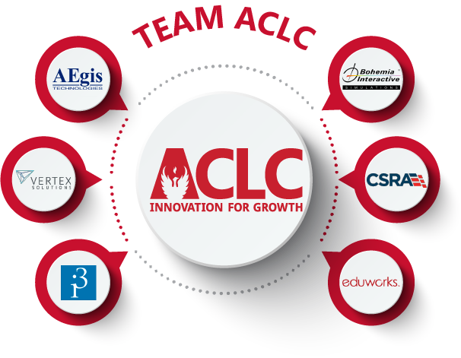
Team ACLC is comprised of the following trusted Army T&E partners:
- ACLC, LLC
- AEgis Technologies Group, Inc.
- Bohemia Interactive Simulations (BISim)
- CSRA Inc.
- Eduworks Corporation
- Integration Innovations Inc. (i3)
- Vertex Solutions
Our diverse team of seven small, medium, and large companies has developed advanced training solutions for all TRADOC Centers of Excellence.

About Eduworks Corporation
Eduworks develops leading edge technologies based on text analysis, machine learning, and data science. Eduworks applies these techniques to create force multipliers that accelerate learning and enable people to do their jobs faster and better.

